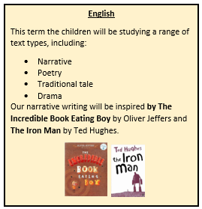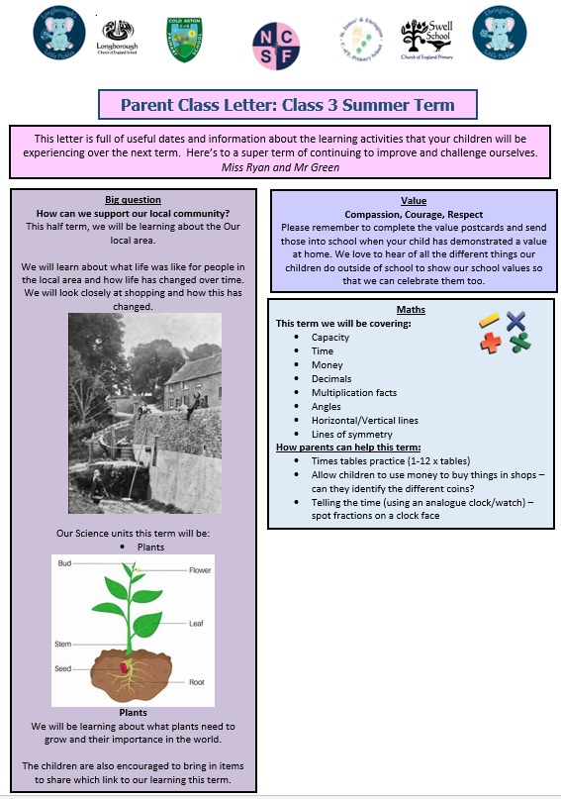

# PSHCE

During this term, the children will be learning about The Family. Looking at the differences and similarities between families .

We will also spend time recognising and developing our feelings. We continue to use the Zones of Regulation to support our emotional awareness and abilities to regulate our emotions and behaviours.

**Medicines and Allergies**

If your child has a prescribed medicine (such as an inhaler or Epi-pen), please ensure that we have one in school. This must be clearly named and it is the parents’ responsibility to ensure that the medication is in date. If your child has an inhaler, we also require a named ‘spacer’ (e.g. Volumatic) to ensure that the correct dose is taken. In order for children to take any medication, parents must fill in a permission form from the office. Children will not be allowed to take medicine unsupervised under any circumstances.

**Diary Dates**

Please check the weekly news from the office for key Diary Dates.



**RE**

This term, we have started with a unit about what it is like to follow God, focussing on the story of Noah and the Ark from the Bible. Next half term, we will be asking “How do festivals and family life show what matters to Muslim people?”.

**Homework**

**Reading**

We expect children to read for a minimum of **15 minutes 5 times each week**. Books and reading records need to be in school every day. We encourage children to read their books twice before changing them to improve fluency and comprehension.

Children are encouraged to access Rockerbox News online to complete reading activities 3 times each week. Login details are in their reading journals.

**Spellings**

Spellings will be given out on a Thursday in preparation for a test on the following Thursday. Children should practise their spellings a minimum of 5 times each week. We are encouraging the children to try different ways of practising their spellings from the spellings menu in the back of their folders.

**Times tables**

Times tables are an integral part of maths in KS2. In Class 3, we love to make times tables fun by playing lots of games to help us learn them. Please encourage your child to practise their focus times table daily. A list of great websites and Apps has been stuck in their reading journals.

**PE, Health and Well-being**

Our PE lessons this half term will be focussing on Basketball with Coach Tom.

**PE kit**:

PE is on **Wednesday.**

# Please ensure that your child’s kit is named clearly. Earrings must be removed for all P.E. lessons and long hair tied back.

# If your child needs to be excused from a P.E. activity for a medical reason, please send a note to the appropriate teacher.

**Drinks and Snacks**

Children are encouraged to bring a named, refillable bottle, filled with water only, into school to keep hydrated throughout the day. These will be kept in class where children can access them easily.

Your child may bring a healthy snack (such as fruit) to school to eat during our morning break time.