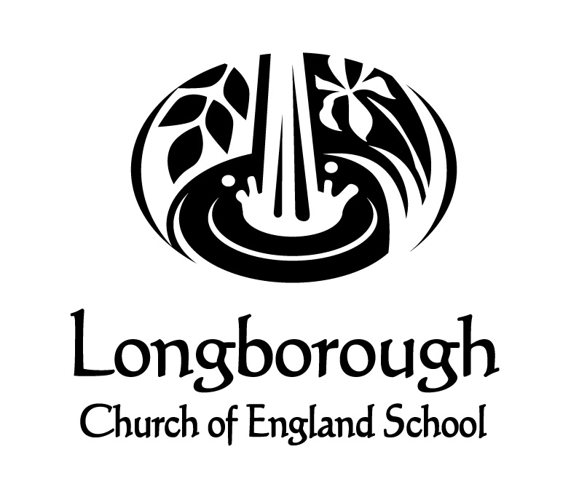
Longborough Class 2 ( Year 1 and 2 )
Key features 2034/24
A school family at the centre of its village community, with a big outward looking heart, where all are enabled to shine as unique individuals, using their well of abilities to flourish as global citizens. (Isaiah 58:11)
School Values | At Longborough we show Love, have Pride and are Safe.
 | Compassion |  | Courage |  |  | Respect
British Values | Democracy | Liberty |  |  | Mutual Respect and Tolerance |  |  | Rule of Law
Whole School  Wellbeing and Nurture | - Daily check in  - Individual, group and whole class relational practice  - Emotional coaching
Whole School Enrichment | Autumn |  |  | Spring |  |  | Summer
 | Children in Need day  Poetry competition  Health & Well Being day  Mindfulness  House point winner celebration treat  Harvest Festival  Remembrance Day  Christmas Tree Festival  Class Christmas Party  Nativity |  |  | Poetry competition  World Book Day  Health & Well Being day  British Science Week  House point winner celebration treat  Easter service |  |  | Health & Well Being day  Longborough Opera festival and workshops  Scarecrow Trail (alternate years)  Village Fete  Sezincote Teas  House point winner celebration treat
 | Where would you rather live, England or Kenya? | How have Florence Nightingale and Mary Seacole helped to make the world a better place? | How could you advise the three little pigs?
People who have flourished | Kamau ‘Cartoon’ Joseph  Martin Bulinya | Monet  Florence Nightingale | Andy Goldsworthy
Learning within the community | Wellbeing walks around the village  Longborough opera singing  Trip to local allotment – DT link | Well being walks around the village / local area | Well being walks around the village / local area
Key Texts for writing | Meerkat Mail  Malala’s Magic Pencil  The Great Fire of London | The owl who was afraid of the dark  The day the crayons quit | The true story of the 3 little pigs  Plants
Texts to support the ‘Big Question’ | Real Superheros  People who help us | Fantastically Great Women who Changed the World Kate Pankhurst | All about Plants  Homes
Reading for pleasure | The Giraffe, the Pelly and Me  Georges Marvellous Medicine | The Magic Faraway Tree | The Day I fell into a Fairytale
Poetry | The owl and the Pussy Cat- Edward Lear  The Frog – Hillaire Belloc | Desk Diddler – Michael Rosen | If I were in charge of the world
Genre | Narrative  Biography  Poetry  Non-Fiction Fact file | Narrative  Persuasive Letter  Non – Chronological report  Poerty | Narrative  Poetry  Information Text
Speaking and Listening | • listen and respond appropriately to adults and their peers  • ask relevant questions to extend their understanding and knowledge  • use relevant strategies to build their vocabulary  • articulate and justify answers, arguments and opinions  • give well-structured descriptions, explanations and narratives for different purposes, including for expressing feelings  • maintain attention and participate actively in collaborative conversations, staying on topic and initiating and responding to comments  • use spoken language to develop understanding through speculating, hypothesising, imagining and exploring ideas  • speak audibly and fluently with an increasing command of Standard English  • participate in discussions, presentations, performances, role play/improvisations and debates
Maths | Place value, Addition and Subtraction, | Multiplication and Division  Geometry | Measure, Number and Place Value, Statistics
Science | Living things and their habitats | Animals including humans | Everyday Materials and Plants
History | Great Fire of London | Lives of significant individuals  Florence Nightingale and Mary Seacole | Historical events of own locality- different buildings
Geography | Comparing a small area of the UK to a contrasting non EU country  England and Kenya | Identification of continents and oceans and hot and cold places | Mapping  Fieldwork skills
Art | Printing: African patterns  Martin Bulinya | Collage: landscapes using hot/cold colours  Monet - Landscapes | 3D Sculpture:  Andy Goldsworthy  Nature in art
DT | Cooking:  Comparing Food from England and Kenya | Use of mechanisms – levers  Moving pictures | Structures: Out-door shelters  Making a house for the 3 pigs
Music – skills | Use their voices expressively and creatively by singing songs and speaking chants and rhymes. Play tuned and untuned instruments musically Listen with concentration and understanding to a range of high quality live and recorded music.
Context | Peter and the Wolf | Charanga Scheme - My Imagination / Round and Round | Charanga Scheme - Friendship Song / I Wanna Play in a Band
Computing | Computer Systems and Networks – Data Information – Grouping Data | Creating Media: Digital Painting and Digital Writing | Programming  Pictograms
RE | How should we care for others and the world and why does it matter?  Why does Christmas matter to Christians? | What is the good news Jesus brings?  Why does Easter matter to Christians? | Who is Jewish and how do they live?
PSHCE | Me and my relationships  Rights and responsibilities | Growing and changing  Being my best | Keeping myself safe  Valuing Differences
MFL | Greetings
PE | Ball Skills and Dance | Gymnastics and Invasion games | Net / wall games and Athletics

